Network questions

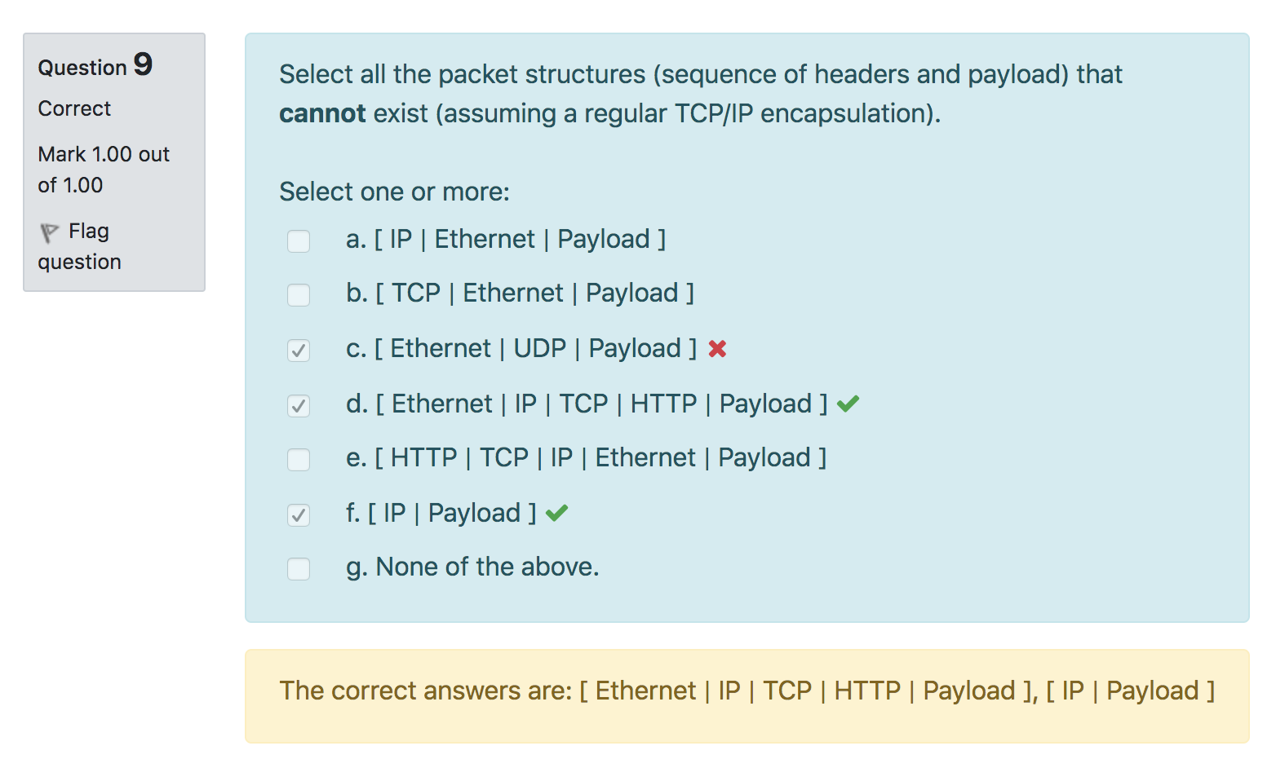

Packet headers in **increasing** order of layers

Then why is Ethernet UDP Payload valid? (L3, L4)

Can have packet that “skips” header? [TCP (L4) | Ethernet (L2) | Payload]

**UDP can’t run with ethernet**

What is DNS alias-sharing and resource-sharing?

Have 1 name be called something else

Resource sharing: can get different records: load sharing

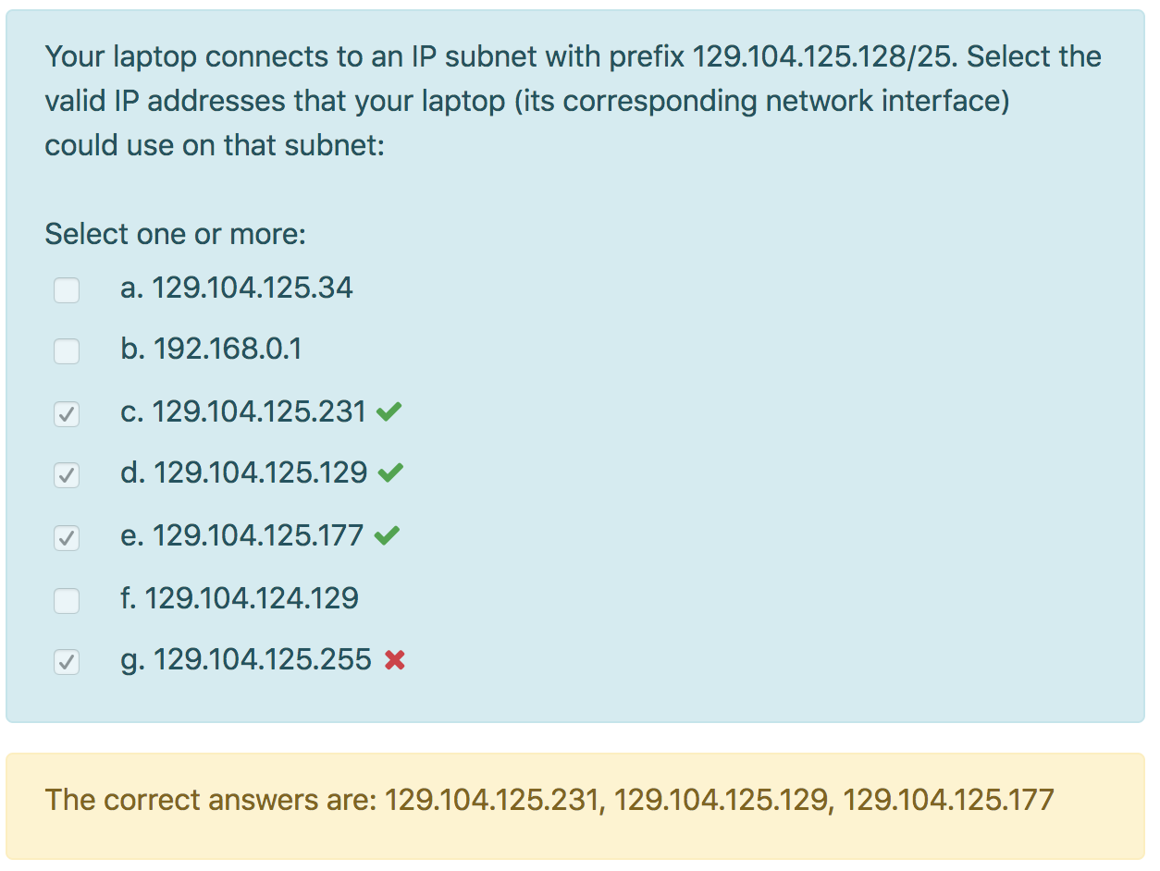

Why can’t use 129.104.125.255? Broadcast address (every bit set to one after prefix: broadcast address)

129.104.125.128/25 : 129.104.125.128 - 129.104.125.225

What is the importance end-to-end principle? Why is it needed for net neutrality? (**NO**) (network features kept at endpoints?)

Internet scalability, no need to assume stuff in between

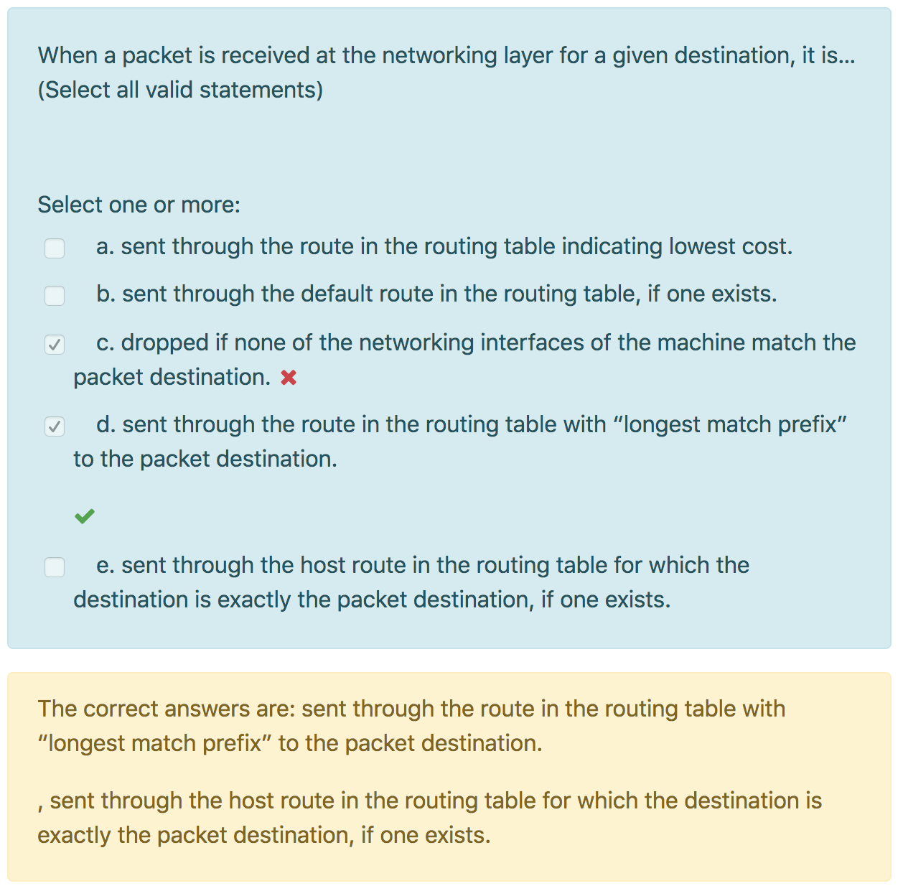

If none of networking interface of machine match packet destination, send through default route if exists? If default route doesn’t exist either, what happens? **Default route: an entry, no default route or entry: dropped**

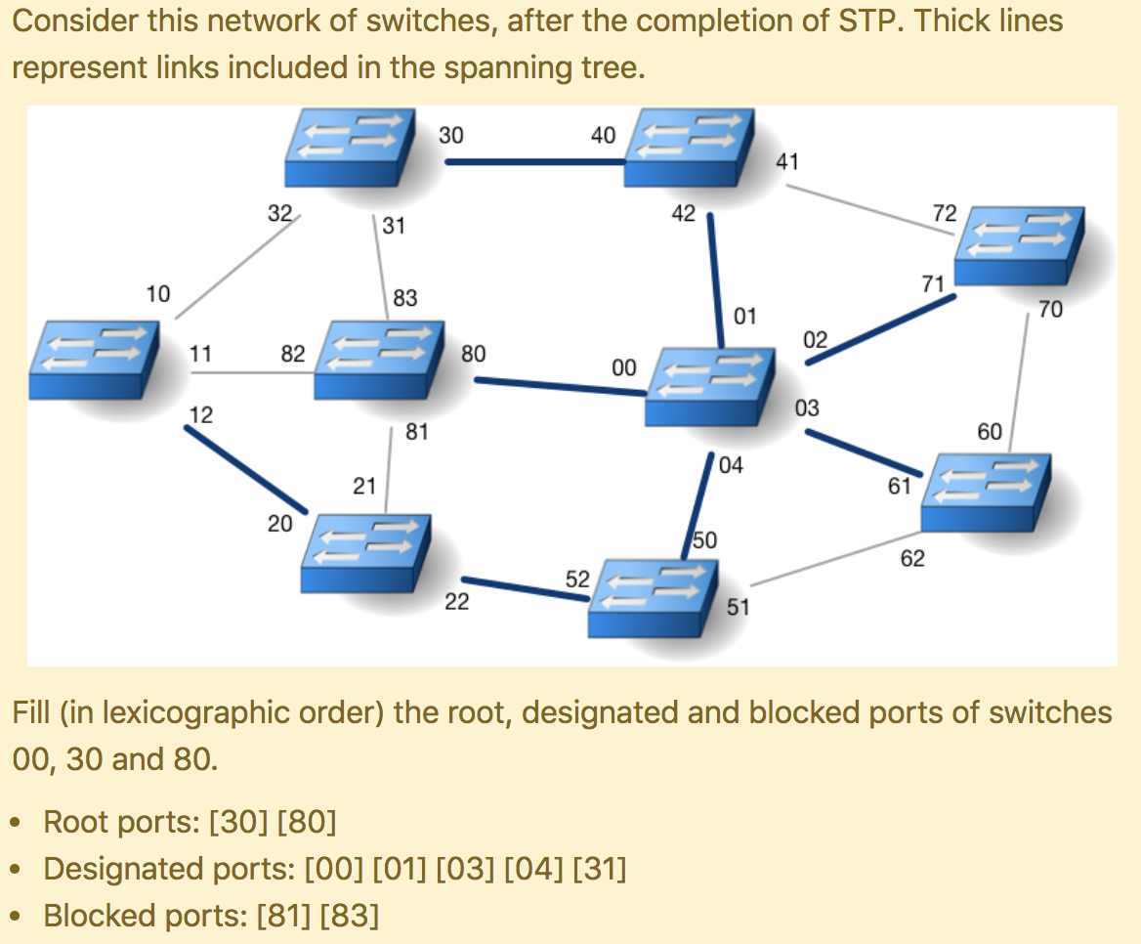

1 designated port per segment, even links not in spanning tree?

Doesn’t Switch 80 have lower cost to root? Why is 31 designated?

Switch 80:

* receive BPDU from root, port 83 receive from 30 (send own packet through 83)
* Port 83 receive 10 (send own packet through 83)

Switch 30:

* receive BPDU from 10, port 31 receive from 80 (send packet through 31)
* Port 31 receive root (don’t send packet)

Link in ST: root + designated

Designated port: willing to accept (but not actually chosen)

Sending a BPDU: “Forward it to me and I can give path to root, here’s the cost”

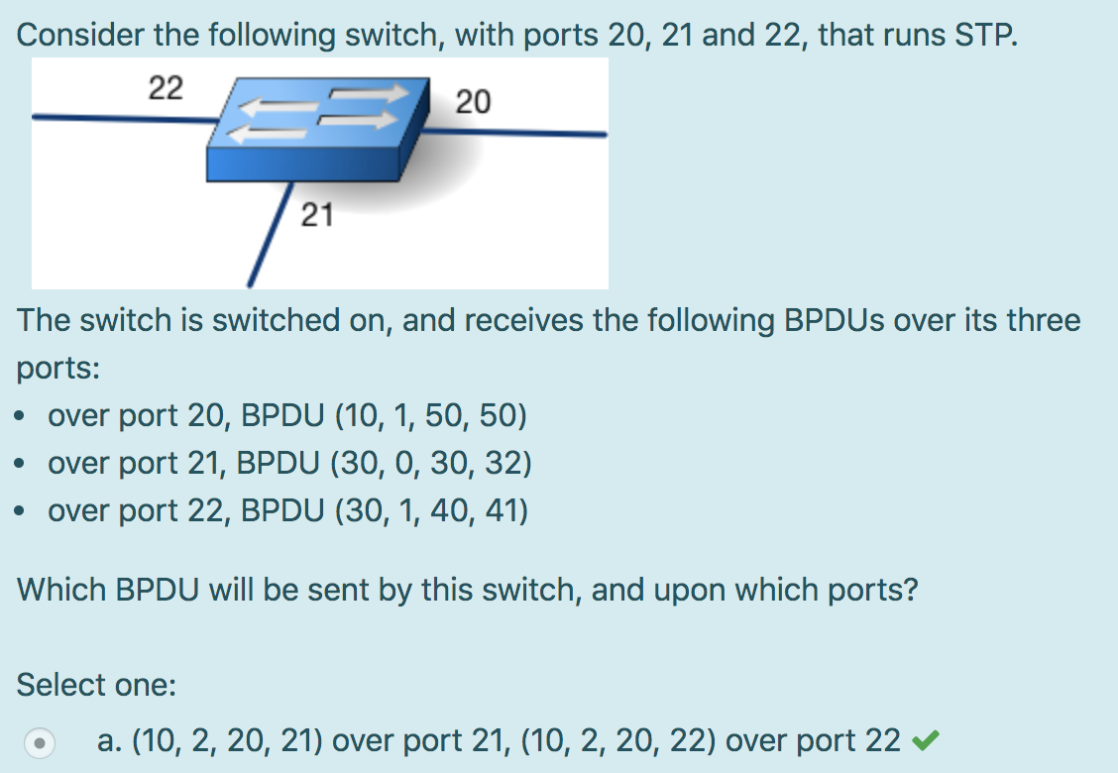

Port 21 send (10, 1, 20, 21)? Cost increment by 1?

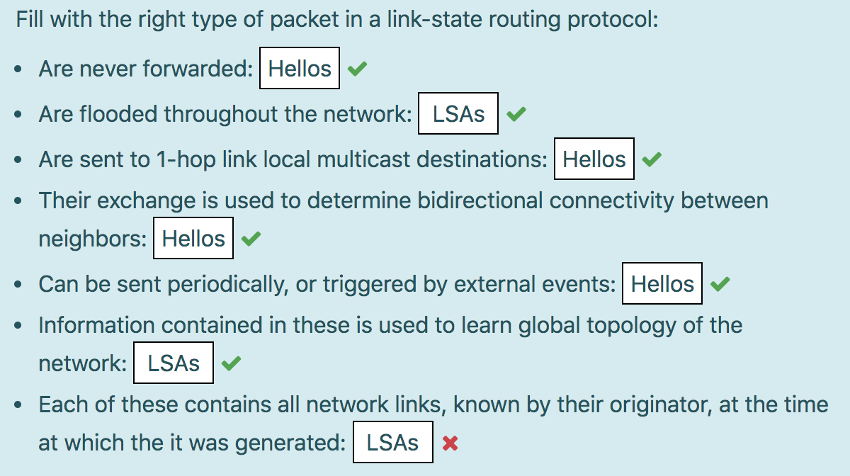

Explain last one, LSA contain just links that belong to originator but not others they know from forwarding by other routers?

Can a single domain have multiple DNS records? Can mul